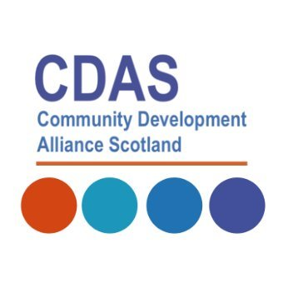

Community Development Alliance Scotland
Case Study Template

Name of organisation

Aims and objectives of organisation

Evidence of Impact
There are sixteen National Outcomes and CDAS is keen to use the National Performance Framework as a guide to measuring the impact of our collective practice.
Please indicate which NPF Indicator/ best applies to your organisation/ projects:
Eg. We have strong, resilient and supportive communities where people take responsibility for their own actions and how they affect others
Tell us about your project -- how have communities been involved in decision-making? What evidence do you have of communities feeling stronger and more confident?
Eg. Communities have indicated that they are stronger, more confident and have been involved in decision making
Main contact

If you have any visual/ digital evidence, please attach it with your email.
Please email to Colette McGarva at cdascotland@gmail.com.

Many thanks!

