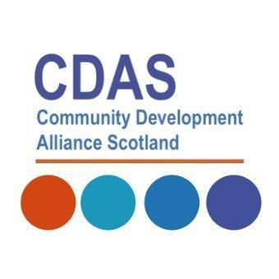

Community Development Alliance Scotland
Case Study Template

- WHY community development?
- Exploring how community development happens
- The impact on communities.

The aim of gathering examples of good practice case studies is to demonstrate how your organisation utilises community development in order to impact on the improvement agenda with and for communities. In our appendix we have included some prompt questions which you may wish to consider but not essential.

Name of organisation:

Aims and objectives of organisation:

maximum word count 50
Community Development is a cross cutting discipline.
Please tick boxes below that demonstrate your impact
Health and Wellbeing |  | Economic Regeneration
Cost of Living Crisis / Social Justice |  | Climate Justice
Democratic Participation |  | Learning and Education
other
Please provide details of your project/s showing evidence of impact

maximum word count 100
What does community development mean to you? – please tell us why you adhere to the core values, ethics and principles? Some guidance HERE
and HERE

maximum word count 60

If you have any visual/ digital evidence, please attach it with your email.

I confirm that we have permission to use digital images for promotion and marketing purposes.

Signed/ Main contact ______________________________________________

Please email to Colette McGarva at cdascotland@gmail.com

Appendix : Guidance and Prompt Questions

If you would like to build on the response you have given we have included some nationally recognised prompt questions which you may wish to consider'.

There are sixteen National Outcomes and CDAS is keen to use the National Performance Framework as a guide to measuring the impact of our collective practice along with other frameworks.

Challenge questions from How Good is Our CLD?
2.1 Empowered communities | Performance and Outcomes | How good is our CLD | HGIOCLD | National Improvement Hub (education.gov.scot)
- How well are community organisations responding to and addressing local issues?
- How influential are community organisations and activists involved in decision making structures and processes?
- How strong is the sense of belonging and pride in their community amongst community members?
- How do we know we are identifying and supporting those who are marginalised or at risk of being isolated in our community?
- How well do we support community members to feel engaged and involved?
- How do we know if community involvement is informing and affecting positive change?

Challenge questions
How good is our third sector organisation? - Evaluation resource (education.gov.scot)
Impact on communities
1. How well do we support communities to be strong, resilient, supportive, influential and inclusive? What difference is this making?
2. What evidence do we have that the people and communities we work with are more confident, skilled and active as a result of our input? Are they more influential? What is the evidence of this?
3. What positive impacts are we having on the communities we support or affect? How do we know?
4. How successful is our organisation in supporting the people we work with to deliver services in their communities based on identified need? How well do we work with communities to deliver services which meet the needs of the people we work with?
5. How well do we support community groups and organisations to plan, manage and evaluate their work, be inclusive and value social and cultural diversity? What progress are we making with this? How do we know?

